43.7: The binding energy of a deuteron is 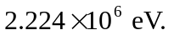 The photon with this energy has wavelength equal to
